**Azure Inventory Discovery Guide**

|  |  |  |  |  |  |
| --- | --- | --- | --- | --- | --- |
| No. | Version | Date | Description | Modified By | Document Name |
| 1 | V0.1 | 2023/04/02 | Generate this guide | Liushaowei | **Azure-Inventory- Discovery-Guide-v0.1.xlsx** |
|  |  |  |  |  |  |
|  |  |  |  |  |  |

## Background

When customer uses Azure Cloud, you want to obtain the Resource Inventory List for the quotation and solution design. You can use this Opensource tool to meet the project requirement.

Azure Resource Inventory Project

<https://github.com/microsoft/ARI>

Azure Resource Inventory - It's a Powerful tool to create EXCEL inventory from Azure Resources with low effort

## Procedures

### Step1: Download the package from Github

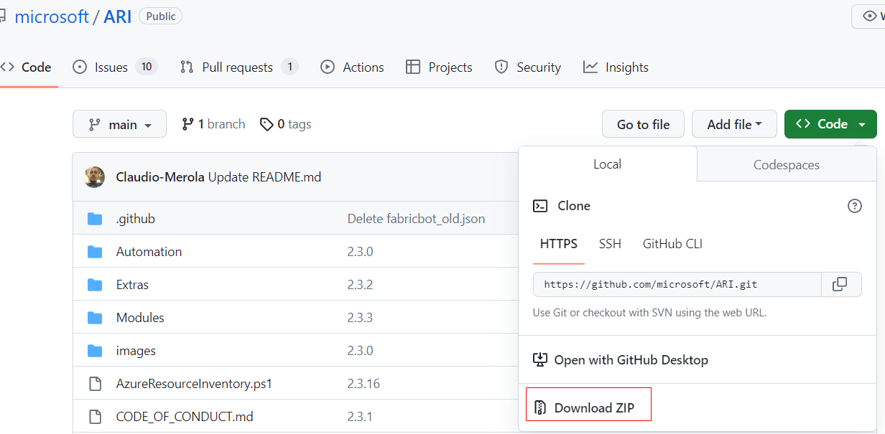

### Step2: Extract the package to local drive.

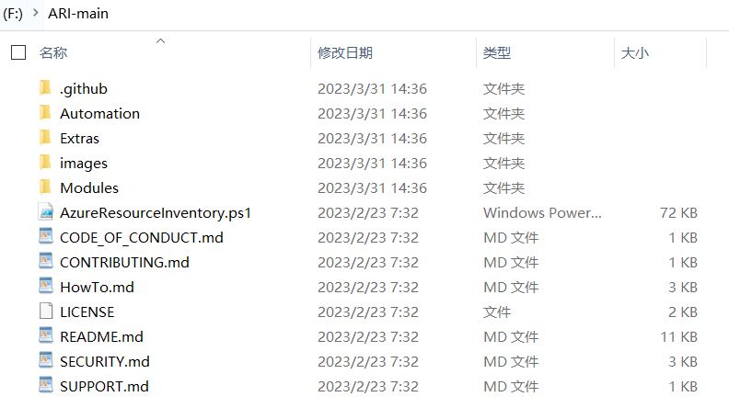

### Step3: (Optional) Install the ImportExcel module.

C:\Users\l00324891\AppData\Roaming\eSpace_Desktop\UserData\l00833414\imagefiles\B34ECF94-E5FA-4B11-AC64-E91F5A94BF42.png

### Step4: (Optional) Install the Azure CLI tool.

[**https://learn.microsoft.com/en-us/cli/azure/install-azure-cli-windows?tabs=azure-cli**](https://learn.microsoft.com/en-us/cli/azure/install-azure-cli-windows?tabs=azure-cli)

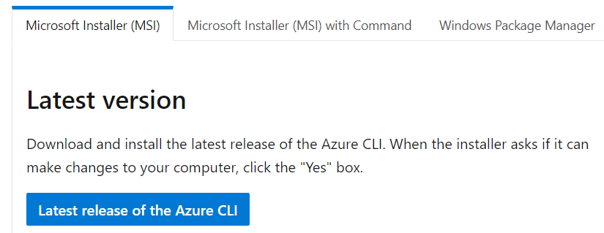

### Step5: Discover the Resource Inventory

PS F:\ARI-main> .\AzureResourceInventory.ps1 -Diagram -SecurityCenter

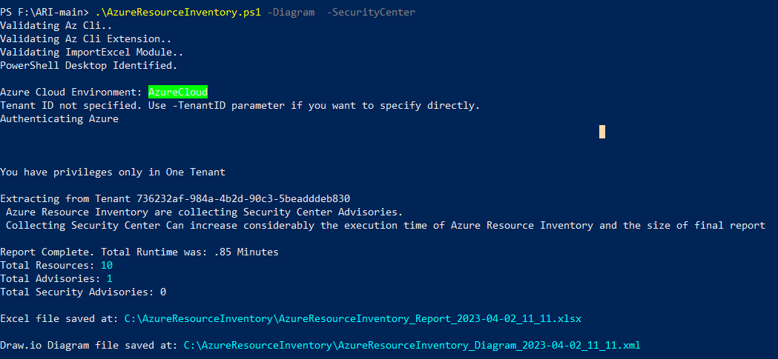

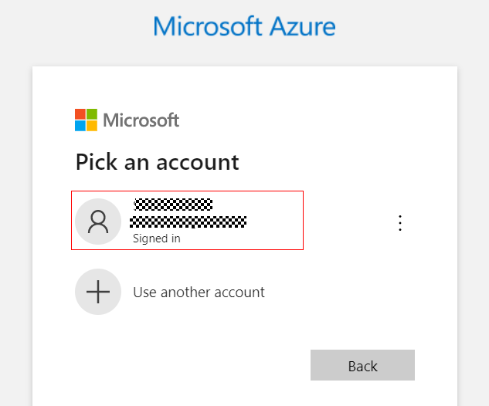

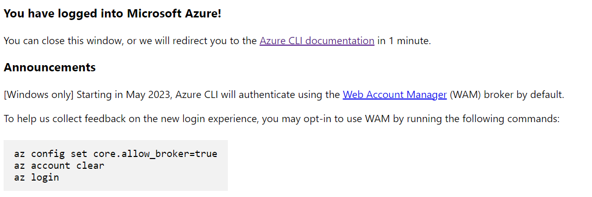



### Step6: Access the report and diagram.

